LE45 ROM FLASH TOOL GUIDE

- Download the flash tool from our website at https://www.lexicontech.com/le45/le45-support/ and launch the flash_tool.exe. It is best to run the tool on Windows 10.

- Click choose at Scatter-loading File field and browse to the ROM location as seen below. Locate and double-click the file called MT6765_Android_scatter.txt to load the ROM component files onto the flash tool.

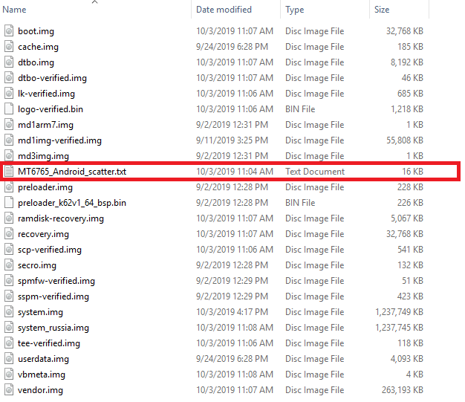

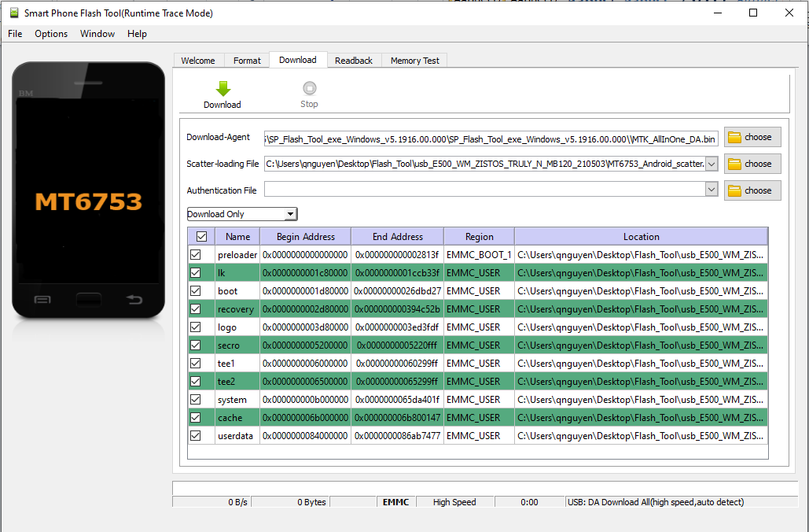
- Verify the components of the ROM image loaded on the FlashTool. Press Download to start loading the ROM to the device.

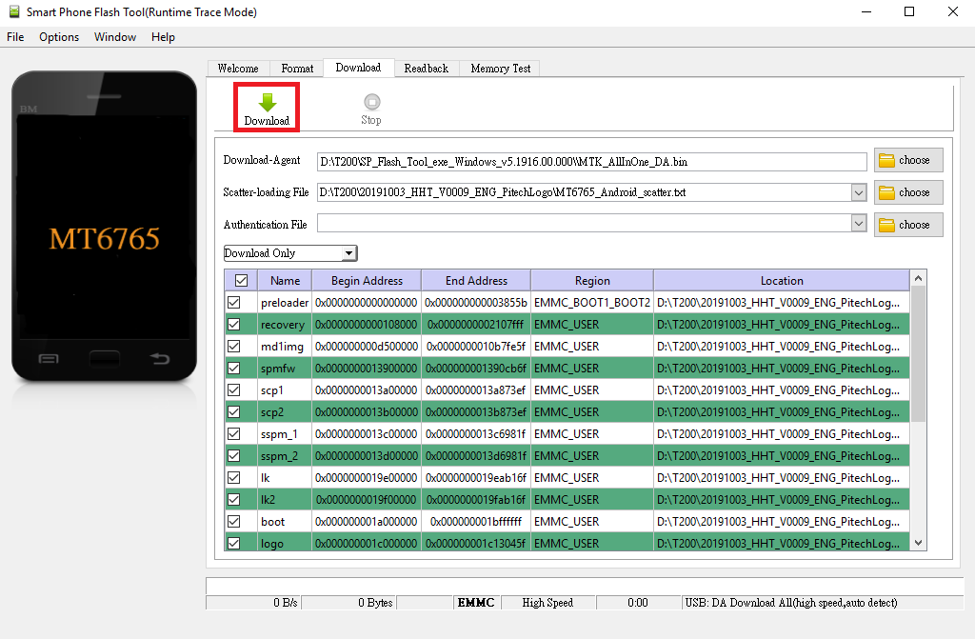
- Prepare a device to connect to the PC.
Remove the battery of the device and connect the device to the PC through a USB cable. The update process will start automatically.

- Disconnect the device once the update is completed.
